The Copper Deposits of the Allihies Area, West Cork, the changing roles of long lived faults in orogenic forelands.
IGA Weekend Excursion: 6th and 7th June 2026.

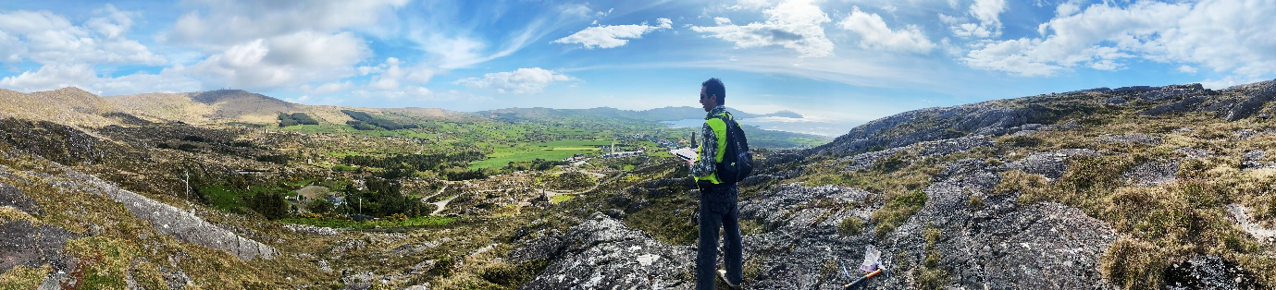
Leaders: Dr Pat Meere and Dr Richard Unitt, University College Cork. To register, see the end of this document.
Pat Meere is a senior lecturer in the School of BEES at UCC and coordinator of the MSCA Doctoral Network ForMovFluid. Richard Unitt is a senior researcher in the School of BEES.
The trip will focus on the role of long lived faults in the genesis of vein hosted copper mineralization in SW Ireland. It will present new data for historic vein-hosted copper sulphide deposits in the Upper Palaeozoic Munster and South Munster Basins of southwest Ireland. Detailed mapping, 3D modelling, fluid inclusion microthermometry and geochronology from the Allihies area of the Beara Peninsula, have led to a new interpretation of the timing and development of ore mineralisation in the area.
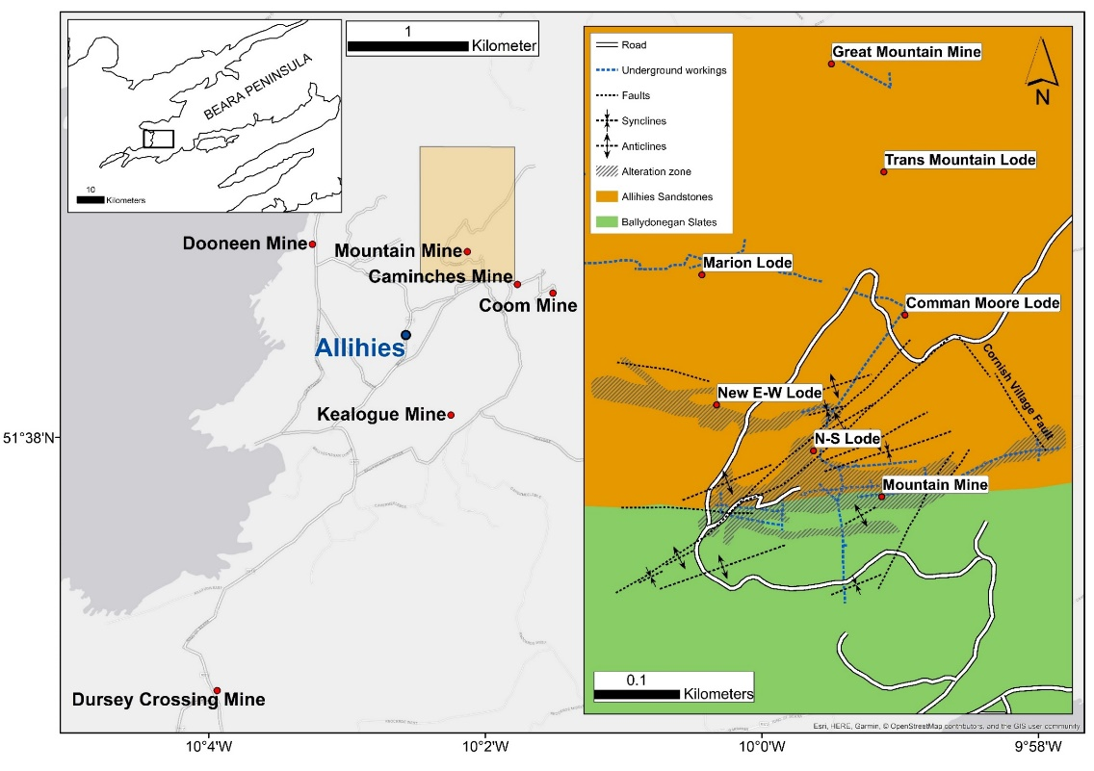
Macro- and microstructural studies reveal that the ore bearing, mainly E-W striking quartz veins are directly related to early extensional normal faults. Molybdenite Re-Os dating of the main-stage Cu lode yield ages from 367.3 ± 5.5 to 366.4 ± 1.9 Ma. This early vein system experienced subsequent late Carboniferous Variscan deformation, including cleavage development, sinistral SW-NE strike slip faulting, cataclastic deformation and recrystallization. The new timing of Cu mineralisation in SW Ireland has major implications for its relationship to the base metal deposits of the Irish Midlands.
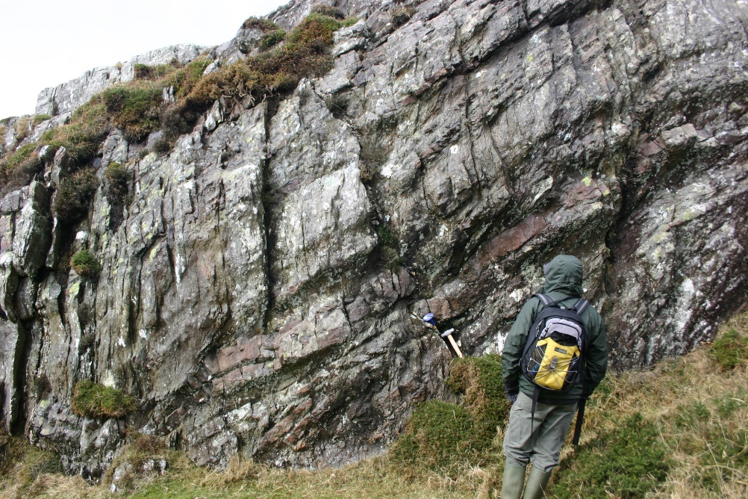
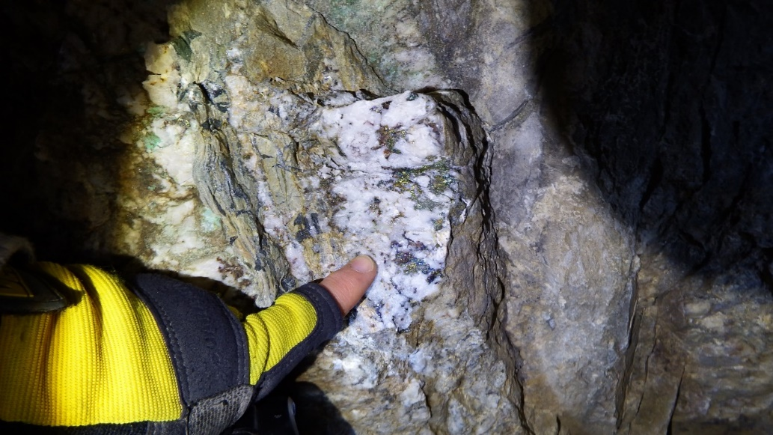

Dress appropriately for weather conditions - waterproof footwear with ankle support is advised. There will be some short periods of moderate exertion on both days.

Accommodation and Transport
The only practical option to get to Allihies is by car. We would encourage people to car share as much as possible.
Allihies has a very good hostel with private rooms (Allihies Copper Mines Lodge – Beara Peninsula) and quite a few B&Bs including the Sea View B&B in the village and Beach View B&B just outside the village.
O' Neill's Bar & Restaurant in the village of Allihies offers excellent evening meal options.
This is the weekend of the Michael Dwyer trad music festival, so please move quickly re accomodation as soon as your place is secured.

Proposed Itinerary
Day 1 – June 6th
10.00am: Meet at Allihies Copper Museum/Café. (grid ref. 51.639040, -10.045630, location link = https://maps.app.goo.gl/XqGsxDw7w5dq9au98). From here we will walk to the Mountain Mine (< 1km). We will mainly concentrate on the Mountain Mine deposit in the morning.
1.00pm: We will return to the Copper Café (https://acmm.ie/thecoppercafe/) for lunch and a museum visit.
2.30 pm: We will make short visits by car to Coom, Dooneen and, time permitting, Kealogue Mines.
5.00pm: End of Day 1 Excursion.

Day 2 – June 7th
10.00am: Meet at Allihies Copper Museum/Café. Drive east on southern side of the Beara Peninsula stopping at Blackball Head, Hungry Hill, Healy’s Pass and finishing in Kenmare.
2.00pm: Lunch in Kenmare, lots of café options.
3.30pm: Waulsortian limestone localities near Kenmare Harbour.
4.00pm: End of excursion.

Registration. To register please click HERE and complete the online form. Numbers are restricted, so you will be contacted subsequently to confirm your registration or to advise you that you are on a wait list.

